“Introduction to Linux: Tutorial”

# What is Linux?

In short is it an operating system or OS. It comes in many distributions or flavours most notably Red Hat, Debian and Ubuntu. An Operating system allows us to work with the computer via either a Graphical User Interface (GUI) or via the Command Line Interface (CLI) to input commands and see the results. For this training course we will be using Ubuntu.

# A short history lesson

Linux is in fact an offshoot of Unix. Unix was developed by Bell Labs in 1969 with the aim of allowing multiple users to work simultaneously. By the early 90’s Unix had become so commercially important it started to become involved in legal issues which resulted in the appearance of Linux, a free OS similar to Unix.

# So that’s the History, what about the present?

From its humble origins Linux has expanded out to become the most ported operating system to computer hardware platforms across the globe. It’s a leading operating system on servers, mainframes and supercomputers alike to the point in June 2013 over 95% of the world’s 500 fastest supercomputers were running some variant of Linux, we won’t mention that Linux dominated the top 44 entirely. It is also embedded into many systems (this means built into the firmware) and tailored specifically to these systems; many of you are probably even carrying a little bit of Linux around with you now in your pockets (android phones).

# Why do we use it instead of another OS?

Because Linux is a free open-sourced program it means that not only is the cost right but also that anyone is able to see the source code so when a bug is found there is potentially an entire community, that’s millions of developers and coders, looking into the bug usually getting it patched in a very short time. There is also the added benefit of making the lives of developer much easier as everything is right there in the open for them to look at when creating programs to be used on Linux. Linux also goes a long way to promote open sourcing and freeware of the applications written to run on it, meaning there is a good chance that if you need a program to perform a specific function it may already exist and be free to use.

Another reason that has been suggested is that Linux has the better mascot. Allow me to introduce you all to ‘Tux’. - He’s a Libra, likes Sardines and long walks in the snow.



# How to access the Terminal.

Ok, so now you’re in the GUI side of things, In many ways this is very similar to the Windows or Mac OSX OS ‘s that you are all no doubt familiar with from your home and work PC’s. To access the terminal you will need to look for the following icon on the launch bar on the left.



This should result in a window looking very much like this (familiar to those of you with any exposure to the command line in windows)

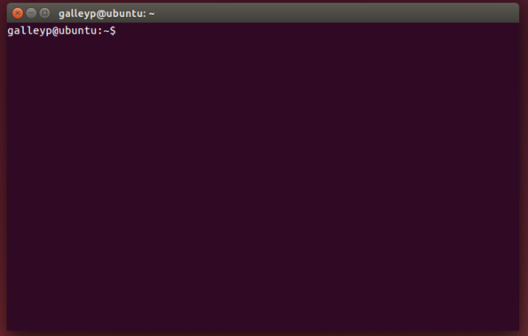

# Basic commands, flags and getting around.

So now we are in the Terminal how do we get the computer to do something? In short you give the computer a command. We will start with some of the informative commands

|  |  |
| --- | --- |
| who | This will display information about who is logged on, both yourself and others. |
| whoami | This will display information about the current user i.e. You! |
| ls | ls is short hand for LiSt. It will display all the visible files within the directory that you are currently in. The files will be listed alphabetically by default but this can be altered with flags. |
| pwd | This will Print the Working Directory. A fancy way of asking the computer to display information about where you are and what directory you are currently working in. |
| apropos *Keyword* | This command followed by a keyword will provide you with information on commands that are related to that keyword. |
| man *Command* | This will provide you with the manual for the given command. |

Should your terminal session ever hang try pressing Ctrl+D

Using these commands you can gather information about the digital world around you, using flags will give you even more control. We will place the flags behind the ls command for demonstrative purposes

|  |  |
| --- | --- |
| ls -a | LiSt All – This will list all of the files in the directory including the hidden dot files. |
| ls -l | LiSt Long – This will list all the files and/or subdirectories with detailed information such as file size, date modified etc. |
| ls -r | LiSt Reversed – This will list the files in a reverse alphabetical order. |
| ls -t | LiSt Time – This will sort the list into a chronological order based on modification time. |
| ls -tu | This list will list them chronologically based on the last access date. |
| ls -R | This list will include the content of subdirectories. |
| ls -S | LiSt Size – This list will be based on the size order. |
| ls -h | LiSt Human – this will make the list human readable format for example the size would be 1.0MB instead of 1004638 |

It is possible to combine flags for instance ls –alh would display all files including hidden in the long format human readable.

The commands for getting around the directories and file structures are really simple and uses an inverted tree like design with the root directory at the top, the user home directory and other essential folders below that, and the general directories/subdirectories below this.



|  |  |
| --- | --- |
| cd.. | Change Directory - to one level up the tree. |
| cd~ | Change Directory - to the home directory |
| mkdir | Make DIRectory – this creates a new directory within the current working directory |
| rmdir *Direcotory* | ReMove DIRectory – This will remove the named directory, It must be within the current working directory |
| rm –r *Directory* | ReMove – the r flag on this command will along with its contents |
| rm –i *Directory* | ReMove – the i flag on this command will make it so there is user interaction, i.e. the computer will ask for confirmation |
| rm –ir *Directory* | ReMove – the combination ir will remove all files within the directory and ask for confirmation for each file within it. |
| mv *filename new_filename* | MoVe – This will move the file to a new location |
| cp *filename new_filename* | CoPy – This will make a copy of the file under the specified name. |

One thing to note is that you cannot move directly between directories on the same level using the cd command alone, you have to either go up a layer using the cd.. then cd to the directory or combine the commands eg.

You are in dir1 and wish to get to dir2  
Route 1 would use the above method of cd.. followed by a command of cd dir2  
Route 2 you could use the command cd../dir2

You can take this one step further and add in the sub directory if known that you want to go to.  
cd../dir2/subdir1

# Tips tricks and cheats

Wildcards, auto completes, command history, quick recall… I bet you wished I had told you about these sooner.

* When searching for files or directories with similar characters or strings in their names you can use one of two wildcards * and ?  
    
  ? is used to match a single character  
  * is used to match multiple characters  
    
  When combining these commands with flags you are able to perform many different functions. A prime example would be the rm flag allowing you to delete multiple files and directories with a similar name.
* When typing in commands and you need to insert a file name you can increase the speed and accuracy by using the tab key to autocomplete. This works best when you are using highly unique filenames, for less unique file names it will only partially complete the file name, up to the point it no longer becomes unique
* The up and down arrow keys will recall previously typed commands and the left and right keys will allow you to edit them.  
    
  The history command will also allow you to see a list of previously typed commands.

# Basic Exercises

Now you have read about the commands, let’s give some of them a try. In your own time try performing the following actions, referring to the prior sections where necessary.

# Summary

Linux is not scary, it’s just taking you out of your comfort zone of GUI based operating systems. The Linux community is superb and there are thousands upon thousands of helpful guides, forums and users out there willing to share knowledge and help the new Linux user.

And finally

